Currency Converter
1-Page Summary Report • Extended Python Project (Ch. 14)

Problem Statement
Build a practical Python Currency Converter that converts an amount from a source currency into one or more target currencies. The base book project used a live API call (requests) and a single conversion. The extended version must work offline with a fixed rate table, support multi-currency conversion, keep a conversion history, provide an alternate dictionary-of-lambdas implementation, include extra practice drills, and offer a parameterised Monte-Carlo simulation of exchange-rate noise that produces histograms.

Solution Strategy
• Offline-first rates: dictionary of values relative to 1 USD; any pair is obtained by division through the common base.
• Optional API fallback: try live rates; on any failure (or when internet is unavailable) silently fall back to the offline table.
• Multi-target + history: convert_multi returns a dict; every conversion is recorded with a timestamp.
• Alternate dispatch: make_converter builds a dict of lambdas keyed by strings such as "USD2EUR".
• Simulation: run_currency_simulation draws noisy rates (relative σ) and plots four histograms so learners can instantly see the effect of rate volatility.

Solution
Core functions: get_exchange_rates, convert, convert_multi, record_conversion, show_history, make_converter, run_currency_simulation. Sample offline results (rates fixed for reproducibility): 100 USD → 92.00 EUR; 50 EUR → 42.93 GBP; 250 EUR → 271.74 USD / 214.67 GBP / 40 625 JPY / 139 945.65 CRC. Cross-rate check USD→EUR→GBP equals USD→GBP exactly. Tourist budget of 1 000 USD expands to 920 EUR, 790 GBP, 149 500 JPY, 515 000 CRC, 1 360 CAD. Simulation (n=800, σ=3 %) centres tightly on the true values; raising σ to 8 % visibly widens every histogram.
Figure 1 – Program flowchart
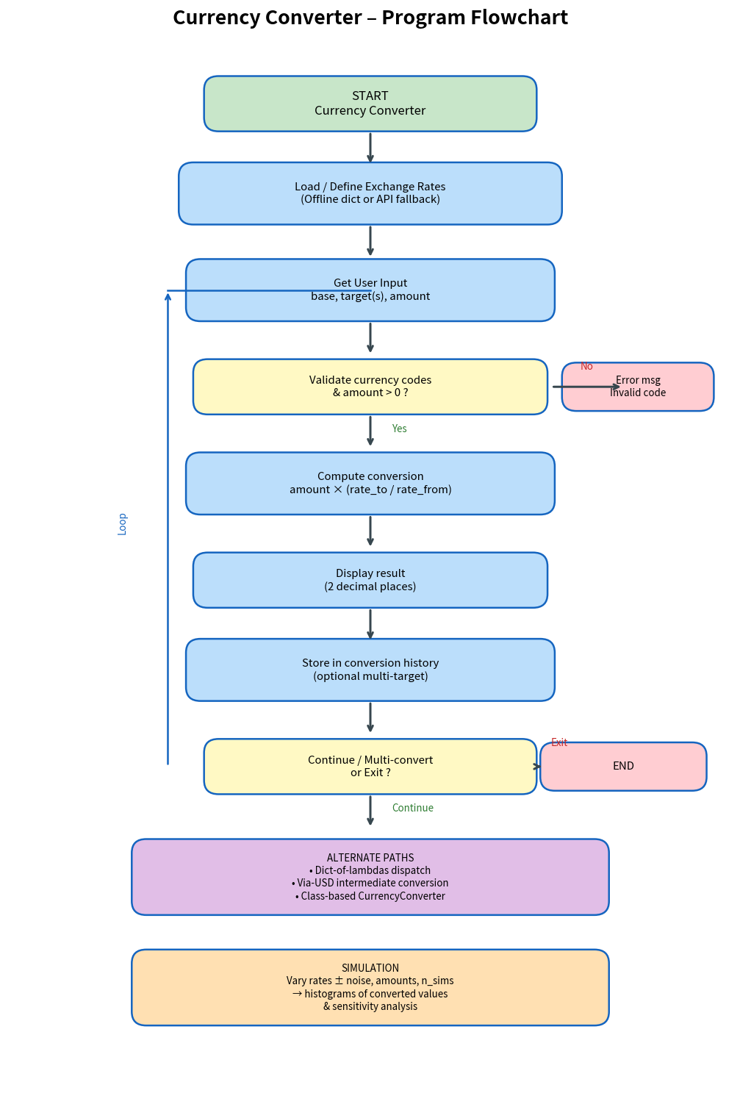
Figure 2 – Simulation histograms (modify noise_pct / base_amount / seed for different shapes)
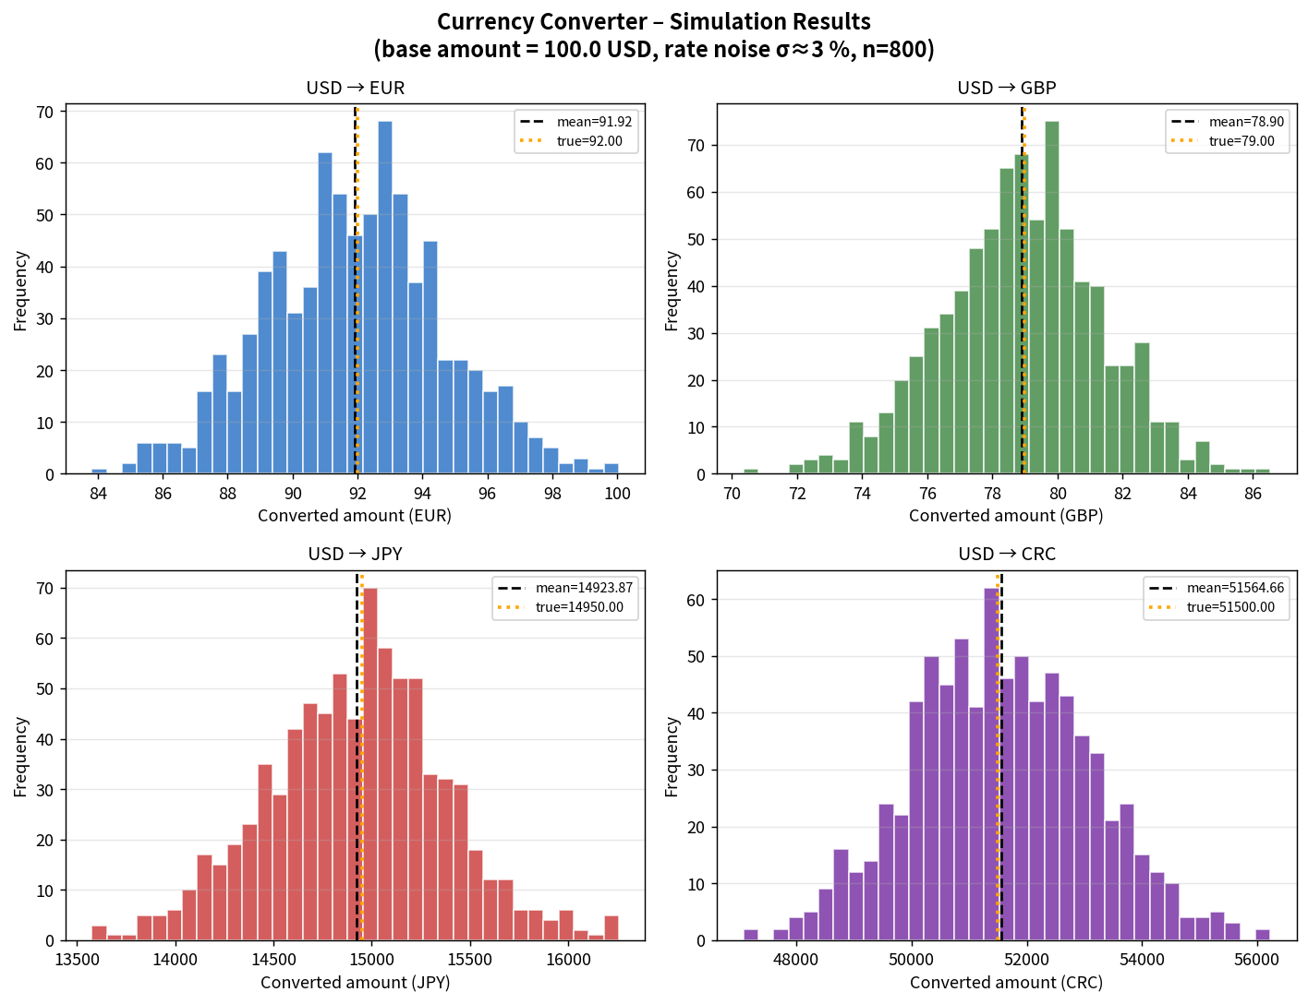

Key Takeaways
• Offline rate tables guarantee reproducibility and work without network access – ideal for teaching and offline notebooks.
• All pairwise conversions collapse to a single multiplication once rates share a common base (USD).
• Dictionary-of-lambdas scales automatically with the number of currencies and eliminates if-elif chains.
• A short history list turns the converter into a tiny audit log ready for later reporting or a GUI.
• Monte-Carlo noise around published rates makes exchange-rate risk concrete for any given budget.
• Deliverables: Practice Skeleton + Solution notebooks, flowchart, simulation chart, standalone .py module, and this summary.

